Tester - Prabhvir

Firebase Database
Test Report

Test Summary

Test Case | What Was Tested | Expected Result | Actual Result | Status | Severity
TC-01 | Add correct trap data. | Data saved successfully | Data saved | Pass | Low
TC-02 | Add wrong data (text instead of number). | Data should be rejected | Data saved with errors | Fail | High
TC-03 | Add missing fields. | Data should be rejected | Data saved with missing fields | Fail | High
TC-04 | Access with different email. | Error or Time Out. | Only authorized emails can access. | Pass | Low
TC-05 | Update data using update() | Only specified field changes | Only specified field changed | Pass | Low
TC-06 | Delete data using delete() | Data removed from Firebase | Data removed | Pass | Low
TC-07 | Error handling – wrong file name | Clear error message | Clear error message shown | Pass | Low
TC-8 | Error handling – wrong database URL | Clear error message | 404 error shown | Pass | Low
TC-9 | Send empty object | Data saved or error | Data saved, retrieval returned None | Pass | Low

Findings / Issues

Issue ID | Description | Severity | Recommendation
Issue - 1 | No security rules, anyone can read/write data  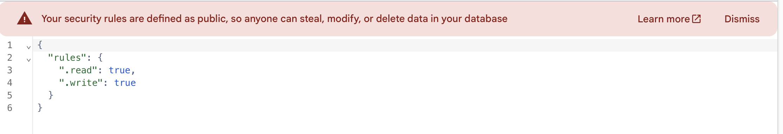 | Critical | Implement Firebase Security Rules with authentication.
Issue - 2 | No data validation, wrong data can be saved | High | Add .validate rules to check data types.
Issue - 3 | Missing required fields allowed | High | Add .validate rules to ensure required fields exist.

Manual Testing or Black Box testing (No Code involved).

Test - Add correct trap data

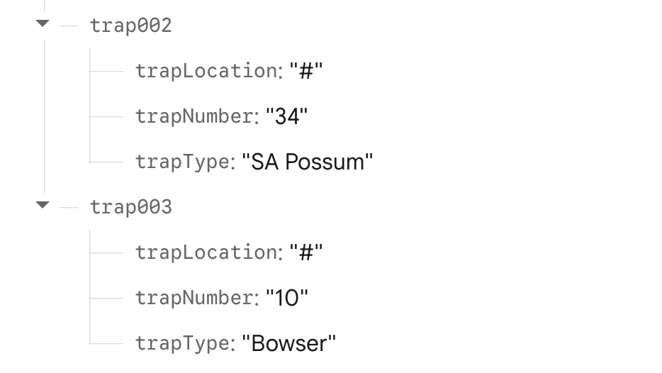

- Data can be added both by code and manually the database is working.

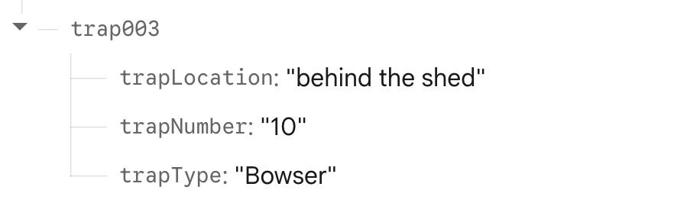

- Successfully update the data manually.

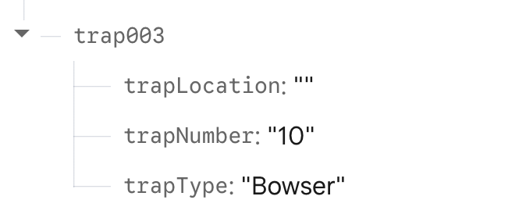

- Delete the updated data.

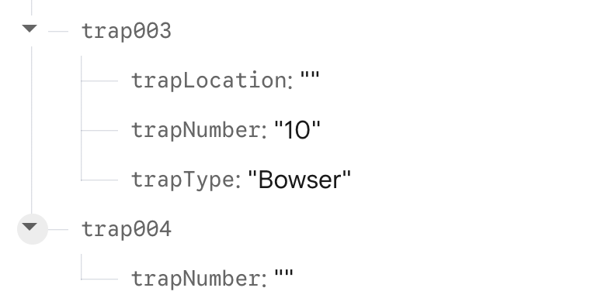

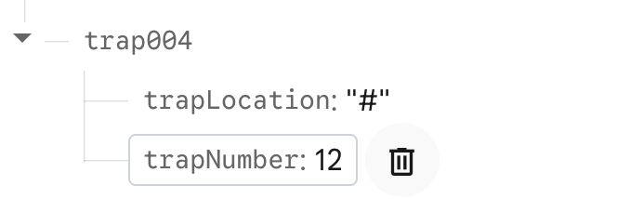

- Successfully Added another trap with limited attributes.

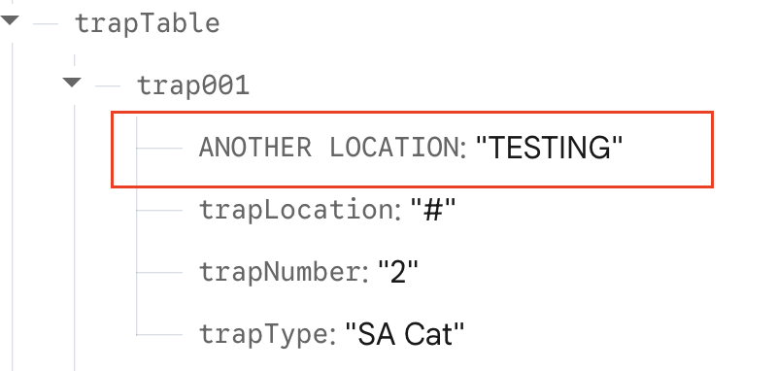

- Successfully added a new attribute to an existing trap record that was originally sent via code.

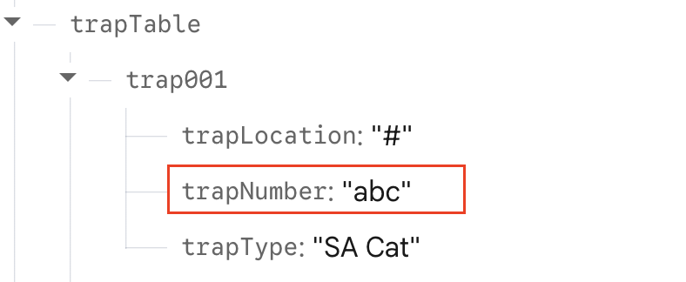

- Successfully added wrong data (text instead of number) to a trap record, Firebase accepted it without any validation.

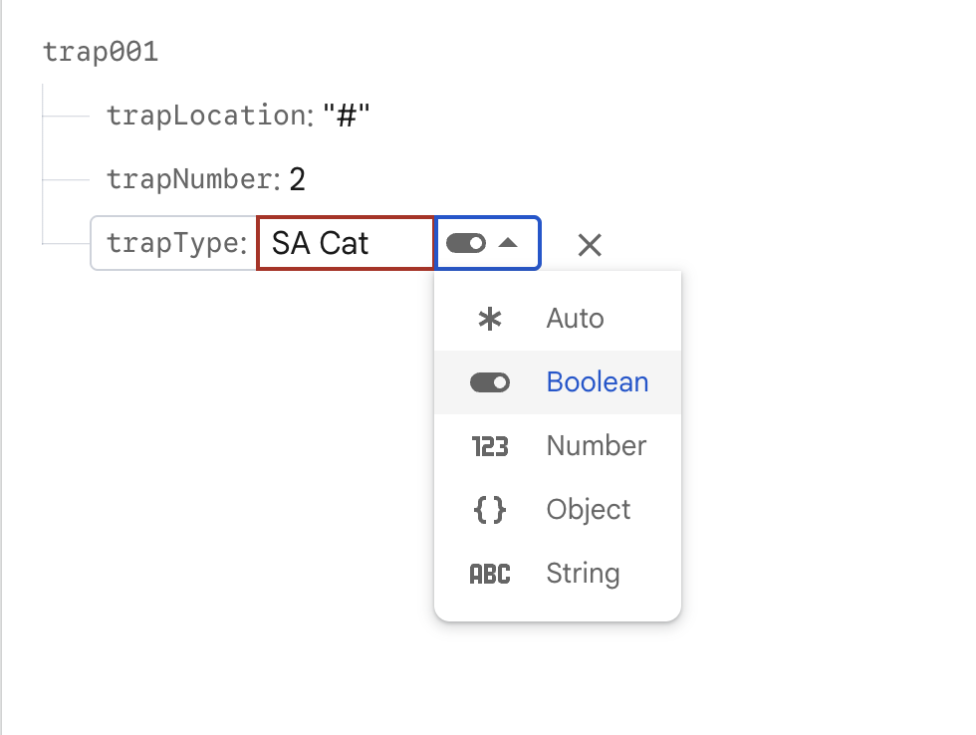

- Firebase automatically brings it to auto then matches it with what I write inside, if it's a number then 123, or whatever else. Firebase automatically detects data types (Auto mode). This means it accepts both numbers and text for the same field.

Manual Testing For transmitter Table.

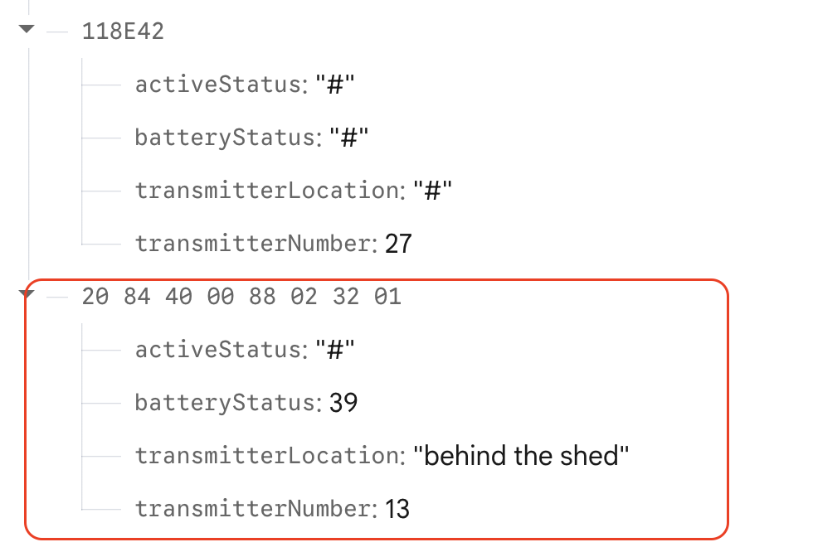

- Successfully added a new transmitter with all attributes — the new entry was saved and persisted after refresh.

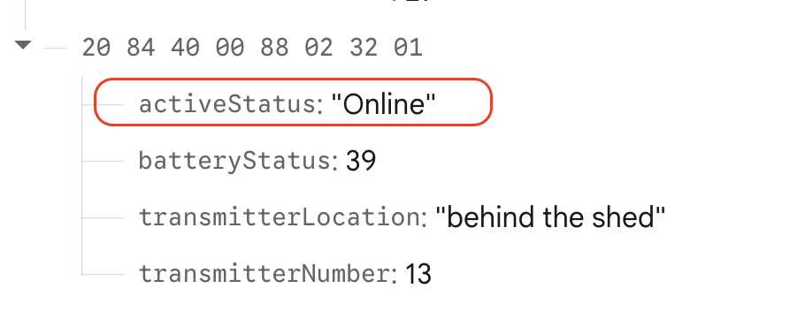

- Successfully updated an existing transmitter record.

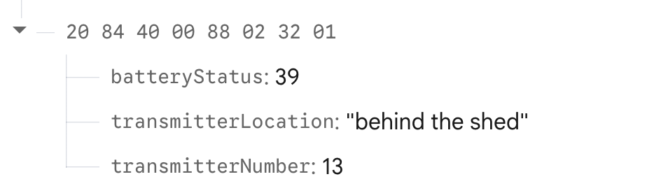

- Can delete any field manually in the record.

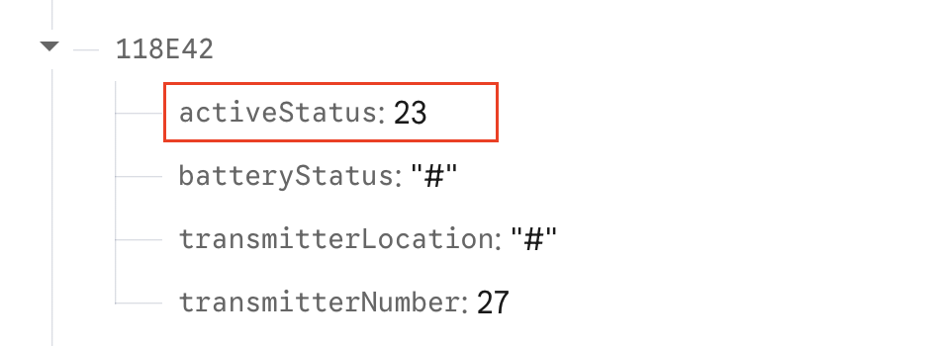

- Successfully updated an existing transmitter record that was originally sent via code.

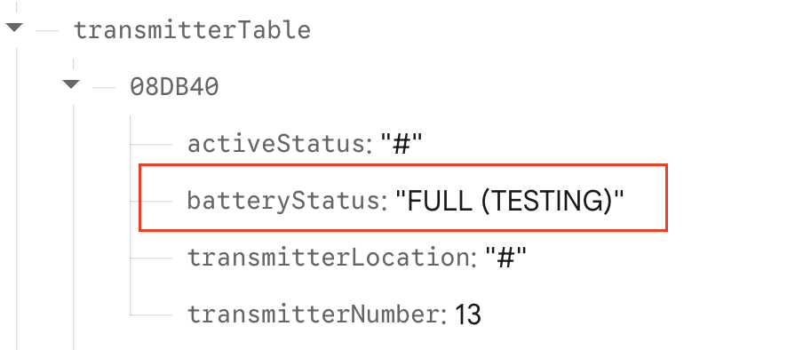

- Successfully added wrong data (text in a number field) to a transmitter record manually, Firebase accepted it without validation.

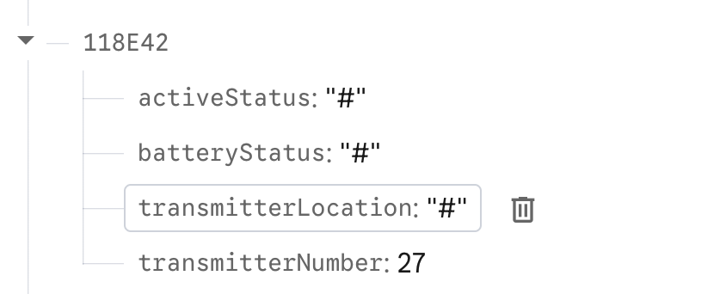

- Back to the original record.

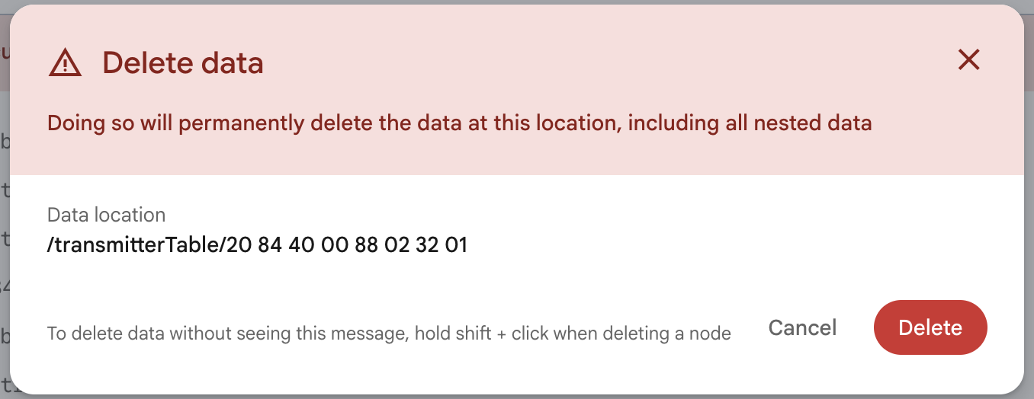

- Successfully deleted an existing transmitter record, manual deletion worked and data was permanently removed.

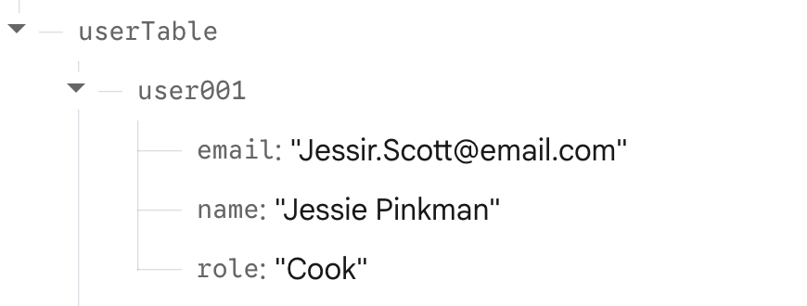

- Successfully edited a user record manually in Firebase that was originally sent via code.

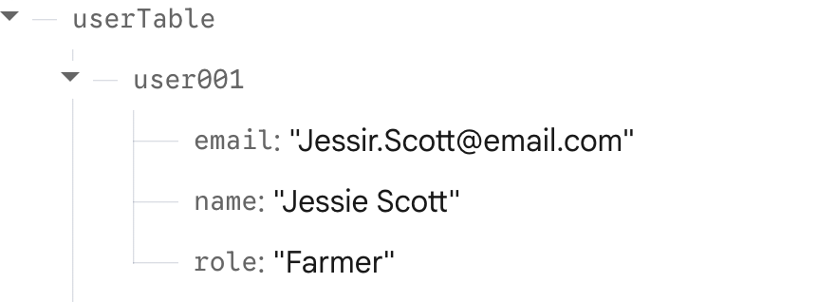

- Back to original.

Security Testing

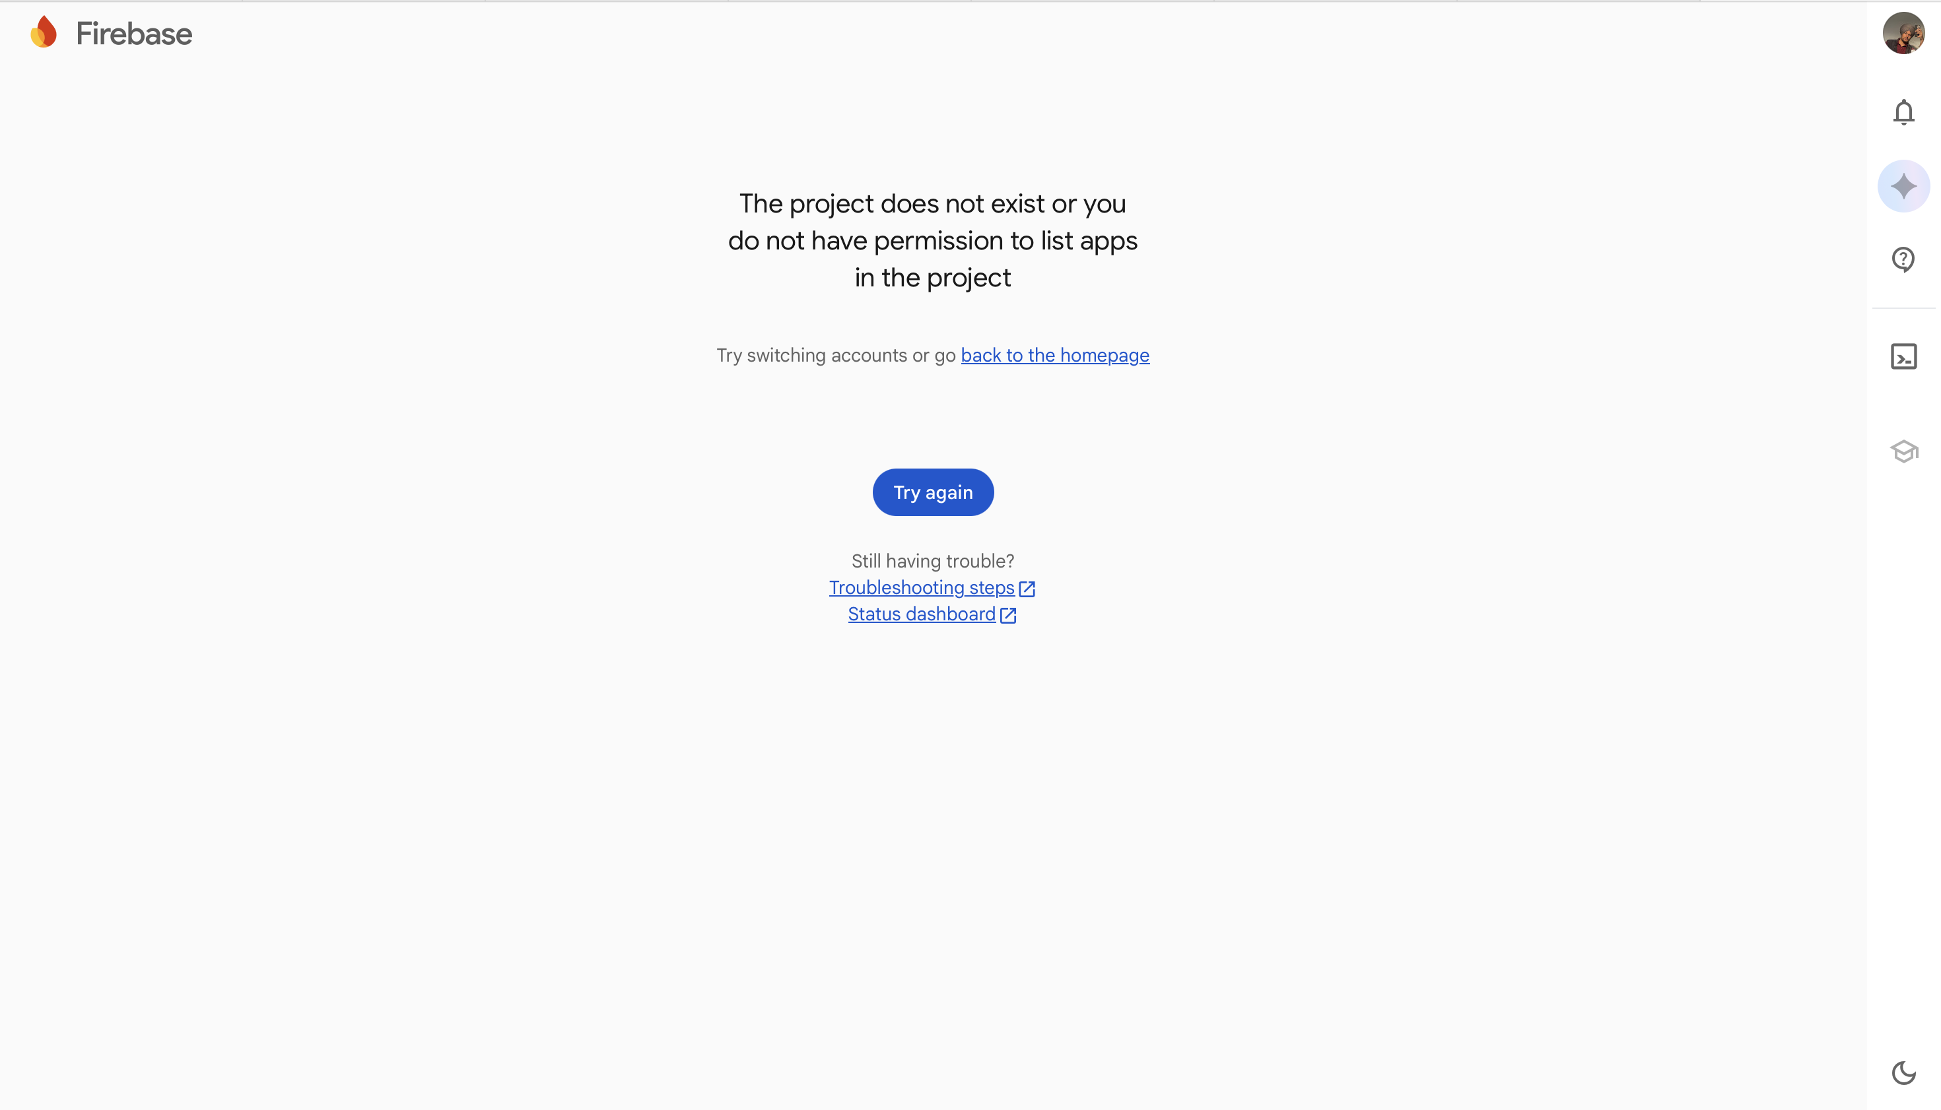

- Security test: Attempted to access the Firebase database using a different email that was not added to the project.
- Access was denied with the error: “The project does not exist or you do not have permission to list apps in the project”
- This confirms that only authorized emails can access the database

Whitebox or Automated Testing

Wrong Data Testing.

- Before

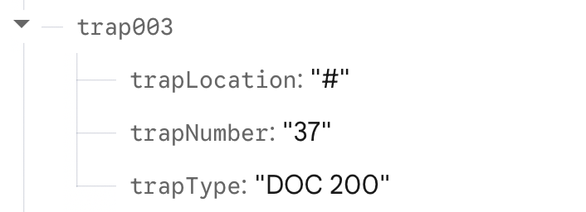

- Change into

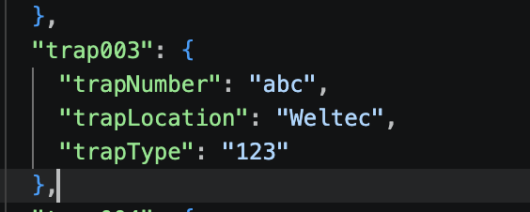

Results:

- Terminal

- Firebase

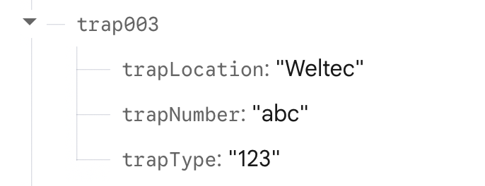

Successfully sent wrong data types to Firebase, trap Number as text and trap Type as a number. Firebase accepted both without any validation or errors.

Delete Data Testing.

Before

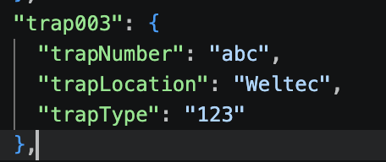

After Delete some Fields

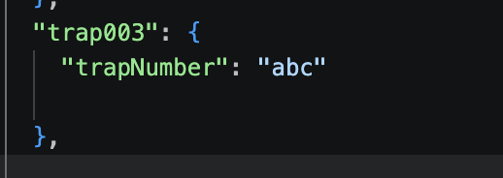

Results:

Terminal

Firebase

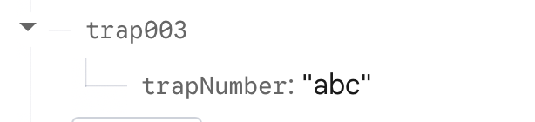

Successfully sent data with missing fields trap003 was saved with only trap Number. Firebase accepted it without any validation or errors.

Delete Trap Testing

Before

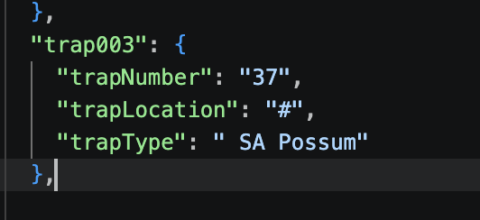

Results:

- Terminal

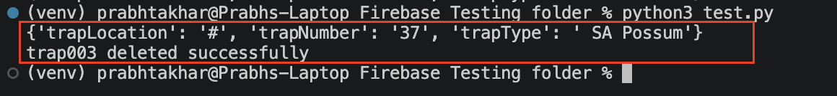

- Firebase (No trap 003)

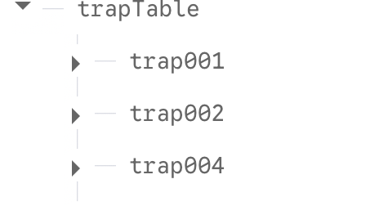

Code to delete the Trap003 in Firebase only NOT in Json file.

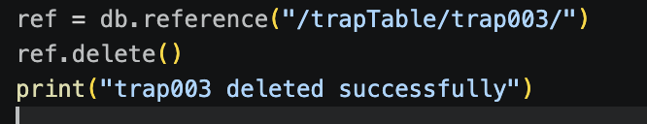

Trap 003 is still in json file.
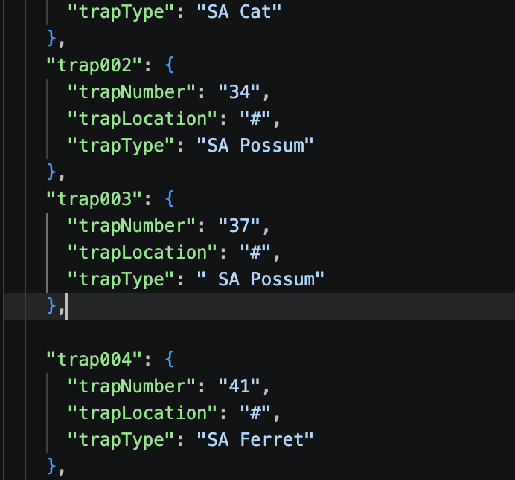

Successfully deleted trap003 from Firebase using ref.delete(). The data was removed from the Firebase database, but the JSON file remained unchanged.

Back to Original data

- Just remove the ref.delete().

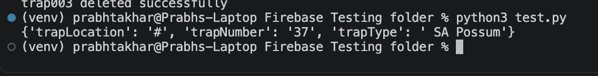

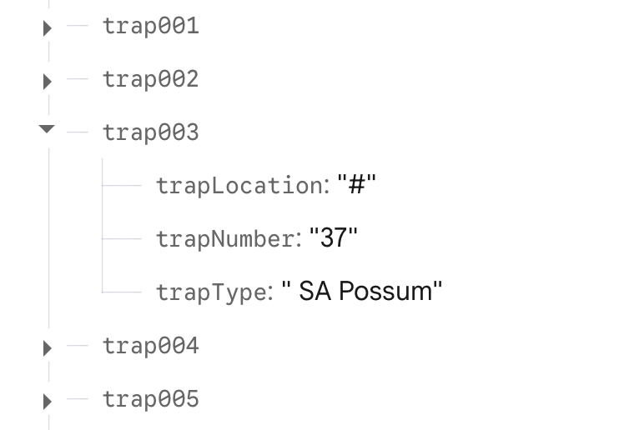

Error Handling Testing Change the json file name to test.

Before

Inside the test.py file

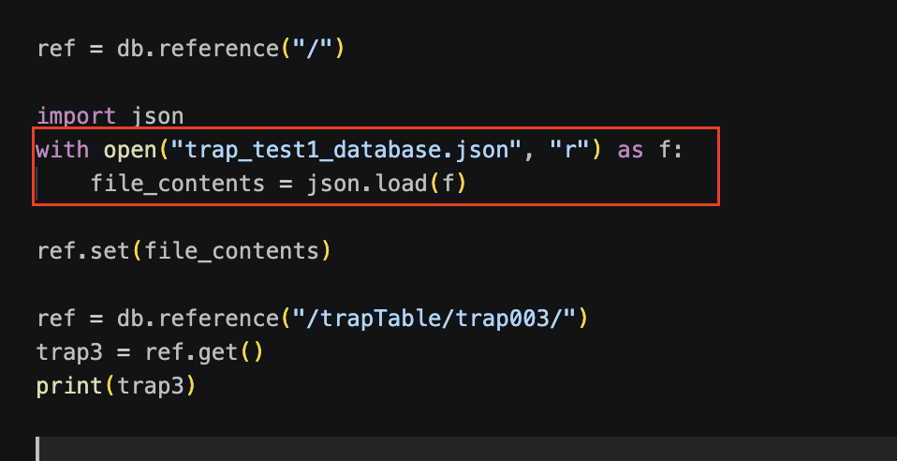

After change the json file name

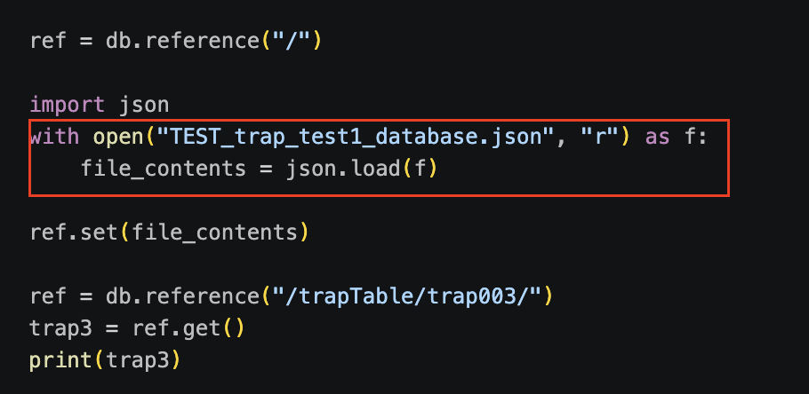

Results:

- Terminal

Failed

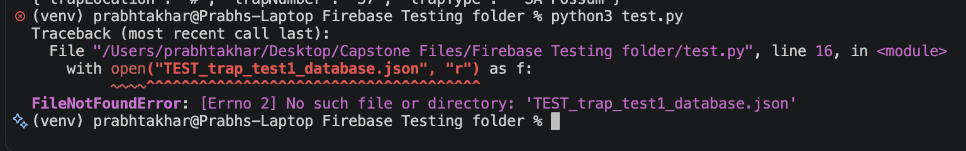

Successfully triggered a FileNotFoundError by using an incorrect JSON file name. The error message was clear and helped identify the exact issue.

Wrong Database URL testing

Before URL in test.py File

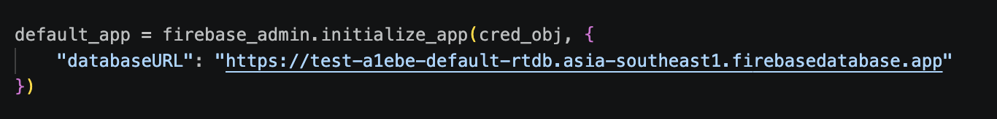

After changing the URL

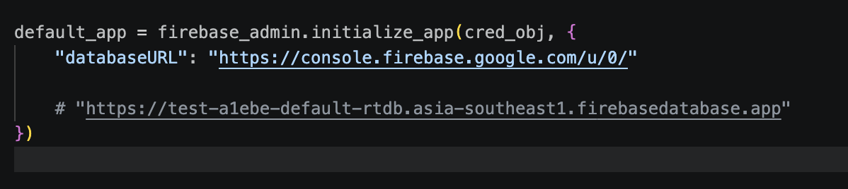

Results:

- Terminal

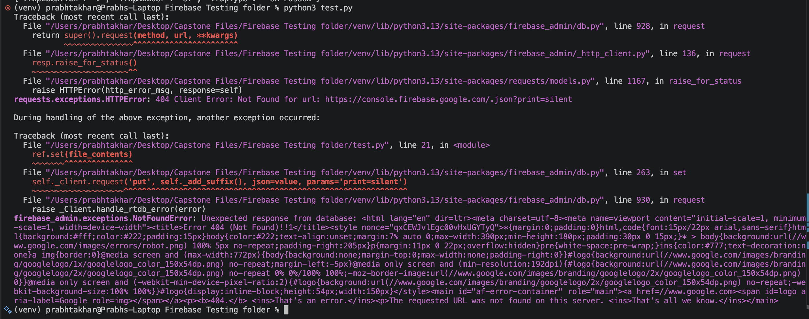

Successfully triggered a connection error by using an incorrect database URL. The error message clearly indicated that the requested URL was not found on this server, confirming that the code handles invalid database URLs properly.

Back to Original

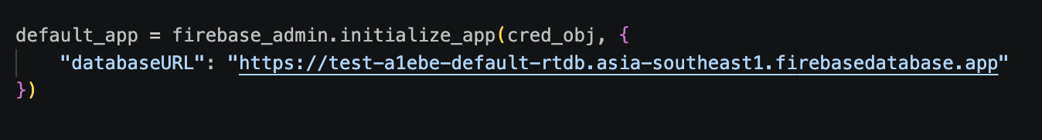

Empty Testing.

Before in json file

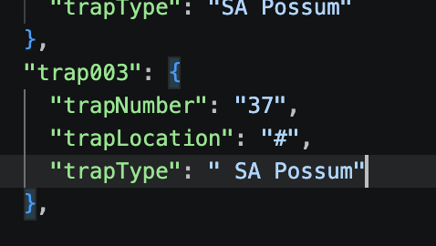

After

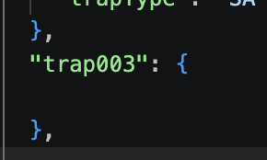

Results

- Terminal

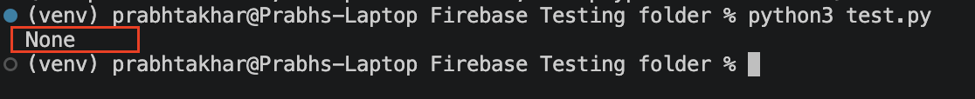

- Firebase

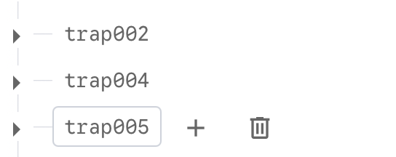

Successfully tested sending an empty object to Firebase. The data was saved, but when retrieved, it returned None because there were no fields to display.

No transmitter table testing?

The Transmitter table follows the same data structure and validation rules as the Trap table. Since the white box testing focused on testing Firebase's behavior with data types, missing fields, and error handling, the results from the Trap table tests are directly applicable to the Transmitter table. Testing the same scenarios on both tables would be redundant and would not provide any additional insights.

Conclusion

The Firebase database successfully handles basic CRUD operations (create, read, update, delete). However, there are critical issues with security and data validation that need to be addressed before deployment. The system currently accepts wrong data types, missing fields, and allows public access without authentication. These issues should be fixed in the next sprint.

